# Tutorial

## Activity 1: HTML <body> Elements

HTML <body> child elements have a number of different properties, for example:

* some have **paired** tags, others have **single / empty** tags
* some are **block** elements, others are **inline** elements
* some can be placed anywhere in <body>, others must be **nested** inside other elements.

Classify the following HTML <body> elements and identify at least one possible parent tag:

|  |  |  |  |  |  |
| --- | --- | --- | --- | --- | --- |
| Element / Tag | Paired | Empty | Inline | Block | Parent Tag(s) |
| <a> | ✓ |  | ✓ | ✓ | <div>, <p> etc |
| <br> |  | ✓ |  |  | <p>, <body>, <header> |
| <div> | ✓ |  |  | ✓ | <body> |
| <em> | ✓ |  | ✓ |  | <p>, <li>, <div> |
| <form> | ✓ |  | ✓ |  | <body> |
| <header> | ✓ |  |  | ✓ | <body> |
| <h5> | ✓ |  |  | ✓ | <header>, <body>, <title> |
| <hr> |  | ✓ |  | ✓ | <body>, <header> |
| <img> |  | ✓ | ✓ |  | <p>, <div> |
| <input> |  | ✓ | ✓ |  | <form> |
| <li> | ✓ |  | ✓ |  | <ul>, <ol> |
| <mark> |  | ✓ |  |  | <p> |
| <ol> | ✓ |  | ✓ |  | <p>, <body> |
| <p> | ✓ |  |  | ✓ | <body> |
| <span> | ✓ |  | ✓ |  | <p>, <body> |
| <table> | ✓ |  |  | ✓ | <body> |
| <th> | ✓ |  | ✓ |  | <table> |
| <ul> | ✓ |  | ✓ |  | <p> |

How are <div> and <span> similar? How are they different?

Similar: Group contents together in a separated part

Different: <div> covers the whole line while <span> only wrap part of the line

## Activity 2: Creating a Table.

A table element is a HTML structure made up of rows and cells that is used to lay out **tabular data** in a **grid** with neatly lined up rows and columns. Occasionally, you will want data or headings to expand to other cell spaces and you use rowspan and colspan attributes to make this happen.

The commonly used tags used to create a table are:

<table>, <tr>, <th> and <td>.

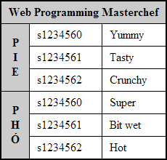

## 

## How many rows and how many columns does the table have before "cell spanning"?

To give a table more structure and "semantic" meaning, the following tags are often included to contain rows and cells:

<thead>, <tbody> and <tfoot>.

These tags are placed inside the <table> tag in any order, but they will always be rendered in the order above.

**Please note:** When designing a layout, it is preferable to use the **CSS Grid layout model** which has many of the benefits of a table but without the fixed structure. Please avoid using tables for layout in your website as they do not adapt well when viewed in small screens such as mobile phones etc.

Tables can still be used but only for tabular data information, but even then always be mindful of the lack of layout adaption on smaller screens.

## Activity 3: Forms and Form Submission

Forms are used to submit data to a processing script. In this course we will write processing scripts in PHP, but there are many server side languages that can process form data.

A form has the following attributes:

|  |
| --- |
| <form action="..." method="..." onsubmit="..." />  <!-- Input controls etc, will cover soon -->  </form> |

What goes in the action attribute?

The method attribute takes either post or get as a value. The post method puts the form data inside the body of the message, whereas get puts the form data inside the url. Discuss the benefits of each method option, think of examples where you would use one rather than the other.

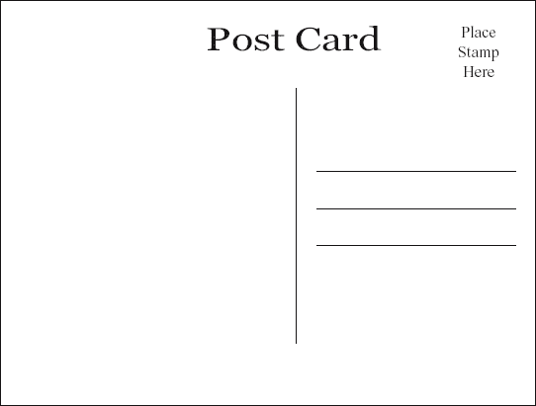

GET

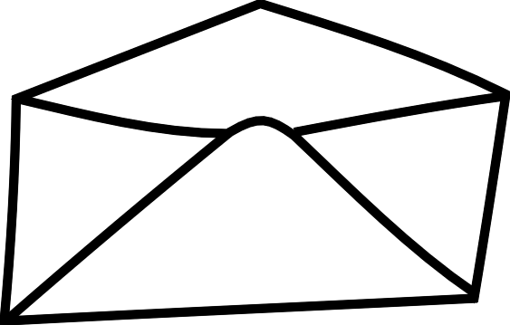

POST

Are there similarities with physical postcards and envelopes?

In the onsubmit attribute, if we write "return checkForm()" and this function returns false, what will happen when a user tries to submit the form?

## Activity 4: Form Elements

### Input elements:

What do each of the following 3 input attributes do? Why are they important:

|  |
| --- |
| <input type="..." name="..." value="..." /> |

What is the difference between text**,** password and hidden inputs? For example:

|  |
| --- |
| Name: <input type="text" name="name" value="" /><br/>  Password: <input type="password" name="password" value="" /><br/>  Rated: <input type="hidden" name="client-rating" value="2 stars" /> |

What is the difference between radio and checkbox inputs AND why are there square brackets in the checkboxes' name attributes?

|  |
| --- |
| <!-- Radios -->  <input type="radio" name="gender" value="male" /> Male<br/>  <input type="radio" name="gender" value="female" /> Female<br/>  <input type="radio" name="gender" value="other" /> Other  <!-- Checkboxes -->  <input type="checkbox" name="seeks[]" value="male" /> Male<br/>  <input type="checkbox" name="seeks[]" value="female"/> Female<br/>  <input type="checkbox" name="seeks[]" value="other"/> Other |

What is the difference between submit, reset and button inputs? For example:

|  |
| --- |
| <input type="submit" value="Buy Now"/>  <input type="reset" value="Clear Form"/>  <input type="button" value="Calculate Something"/> |

### 

### Textarea, Select & Option elements:

These controls have more features, have a different format and are paired tags.

The textarea control is a multi-line text field and has extra attributes to control height and width:

|  |
| --- |
| <textarea name="..." rows="..." cols="..."> ... </textarea> |

The select and option elements are combined to create **Drop down** boxes and **Combo lists**:

|  |
| --- |
| <!-- This will be rendered as a drop down list -->  <select name="...">  <option value="mr">Mr.</option>  <option value="mrs">Mrs.</option>  <option value="miss">Miss</option>  <option value="ms">Ms.</option>  <option value="dr">Dr.</option>  </select>  <!-- This will be a combo box -->  <select name="..." size='...'>  <option value="mr">Mr.</option>  <option value="mrs">Mrs.</option>  <option value="miss">Miss</option>  <option value="ms">Ms.</option>  <option value="dr">Dr.</option>  </select> |

The multiple attribute allows the user to select more than one option. The list loses "radio-like" behaviour and gains "checkbox-like" behavior.

|  |
| --- |
| <select name="..." multiple > ... </select> |

Code up these inputs and draw what each looks like.

### 

### Labels:

For semantic reasons, it is useful to link a label with an input, for example:

|  |
| --- |
| <!-- Text, but no label element -->  <p>Name <input type='text' name='name' id= 'name' /></p>  <!-- Text inside a label element -->  <p><label>Name</label> <input type='text' name='name' id='name' /></p> |

In addition, we can make labels "clickable" by linking the label's for attribute to the id of an input:

|  |
| --- |
| <p><label for='name'>Name</label> <input id='name' type='text' name='name' /></p> |

Useful for text based inputs and very useful for small "hard to click" radio and checkbox inputs.

|  |
| --- |
| <!-- Gender is a "non-clickable" label -->  <p><label>Gender</label>  <!-- But labels below are clickable and increase the usability of the form -->  <input type='radio' name='gender' id='male' /> <label for='male' >Male</label>  <input type='radio' name='gender' id='female' /> <label for='female'>Female</label>  <input type='radio' name='gender' id='other' /> <label for='other' >Other</label>  </p> |

*If there is time, teaching staff will demonstrate some of the new HTML5 input elements and attributes.*